# Overview

Group Policy objects are used in a Windows domain to configure and apply settings to groups of users and/or computers. In this guided practice you will create and link a simple GPO and test its settings

# Objectives

* Configure Group Policy settings and processing.
  + Create and manage group policy objects.
  + Link group policy objects

## Skills Reviewed

* None

## New Skills

* Create and link a group policy.
* Use the Group Policy Modeling wizard to verify a group policy.

## References

Working with Group Policy Objects using GPMC - <https://docs.microsoft.com/en-us/previous-versions/windows/it-pro/windows-server-2012-r2-and-2012/dn789193(v=ws.11)>

Use Resultant Set of Policy to Manage Group Policy - <https://docs.microsoft.com/en-us/previous-versions/windows/it-pro/windows-server-2012-r2-and-2012/dn789183(v=ws.11)>

# Initial Conditions

Your virtual machine should be in this state prior to beginning this guided practice:

* Guided Practice – Creating Active Directory Objects is complete.

# Final Conditions

At the end of this exercise:

* Group policy named **Set Default Home Page** created and linked to the domain. Configured to set the default home page in **Internet Explorer** to <http://google.com>

# Instructions

## Creating and Linking a Group Policy Object

To create and link a group policy, perform the following:

1. Loginto the **Server-01** virtual machine using an administrator account.
2. 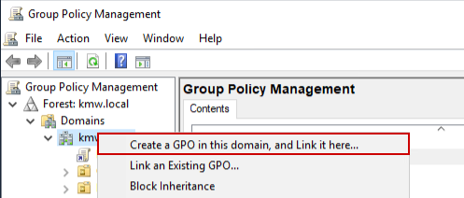Open the **Group Policy Management** console (gpmc.msc).
3. Expand the **Domains** container.
4. Right-click the **KMW.local** domain and choose the **Create a GPO in this domain and link it here** option from the context menu as shown in the figure.
5. 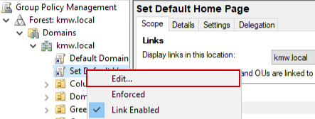In the **New GPO** dialog box, type **Set Default Home Page** in the **Name**: text box and click the **OK** button.
6. Right-click the new policy and select **Edit** as shown in the figure.
7. 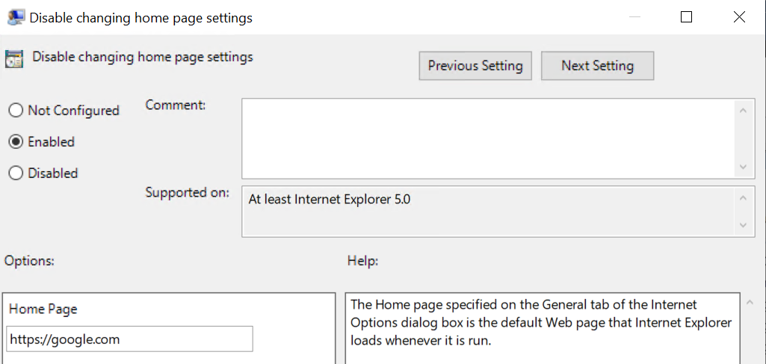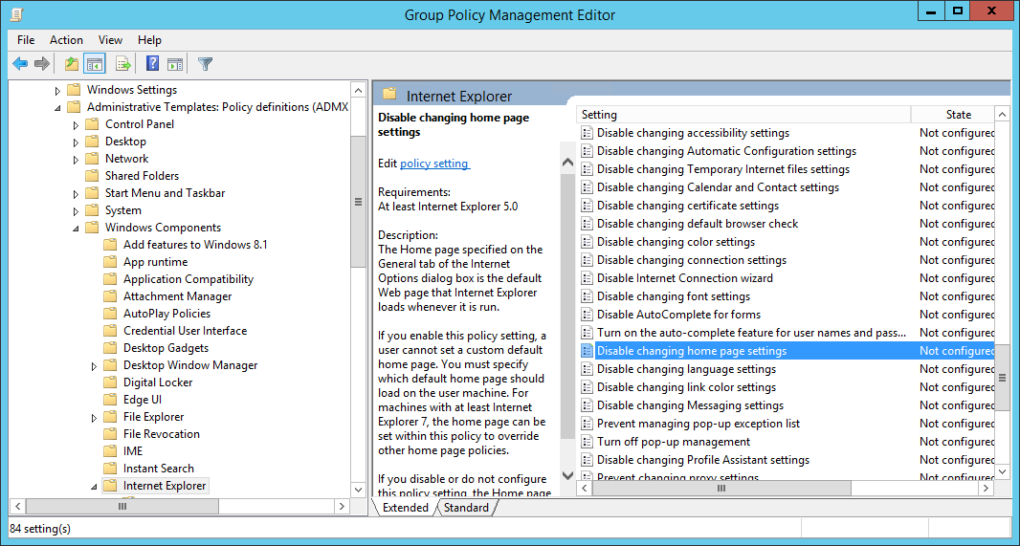Browse to the **User Configuration** node select **Policies→Administrative Templates→Windows Components→Internet Explorer→Disable changing home page settings** and enable this policy and set the home page to **https://google.com** and **click** the **OK** button as shown in the figures below.
8. Exit the group policy editor.

## Verify the GPO settings

One method of verifying group policy settings is by using the Group Policy Modeling wizard.

To verify Group Policy Settings using the Group Policy Modeling wizard, perform the following

1. In the **Group Policy Management** console, right-click the **Group Policy Modeling** node and choose **Group Policy Modeling Wizard** from the context menu.
2. On the **Welcome to the Group Policy Modeling Wizard** page, click the **Next** button.
3. On the **Domain Controller Selection** page, verify **KMW.local** is shown in the **Show domain controllers in this domain** and the **Any available domain controller**… **option** is **selected**. Click **Next.**
4. 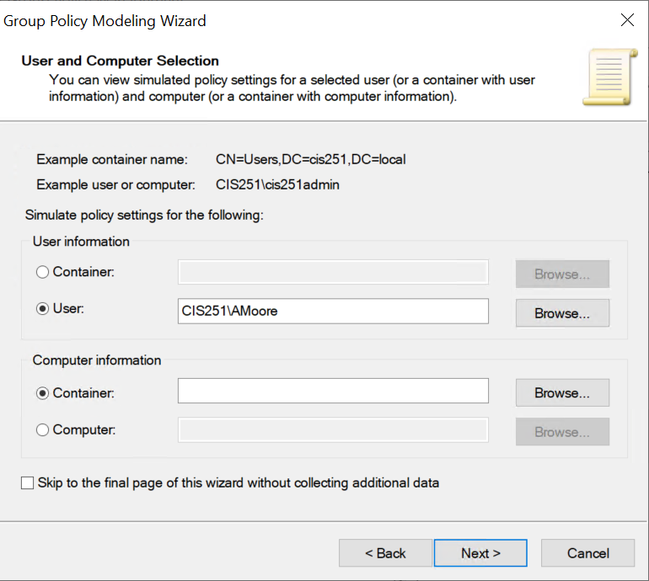In the **User and Computer Selection** page,
   1. In the **User** **information** section select the user **Alan Moore (KMW\AlMoore). Note:** If you get a message that AlMoore can’t be located, check Active Directory Users and Computers for the correct login name**.**
   2. In the **Computer** **information** section, select the **computers** **container** as shown in the figure.
   3. Click the **Next** button
5. Click **Next** until you get to the **Summary** **of** **Selections** page of the wizard, note the options that you have for testing group policy settings. Click the **Next** button.
6. On the **Completing the Group Policy Modeling Wizard** page, click **Finish**.
7. You should now see the results. Note the information in the Summary page.
8. View the **Applied GPOs** on the **Details** page to verify that the policy was applied.
9. **Select** the **Settings** node on the **Details** page and **verify** the **setting** that is being applied.
10. 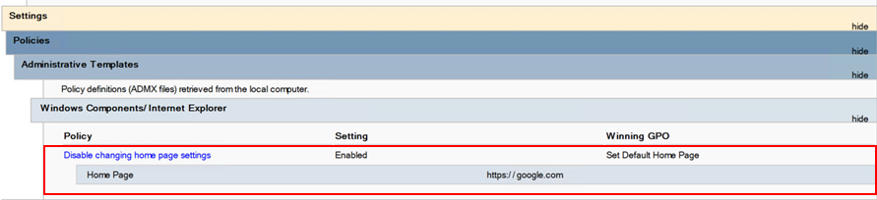You should see the figure below.
11. Exit the **GPMC**
12. Logon to a **Client-01** computer to verify the settings. **Note**: You may have to sign out and sign in before the policy settings are applied.

## Submission Requirements

1. **Download** the **grading** **script** from the assignment page to the **C:\Scripts** folder.
2. Check your lab by running the following command:

Invoke-Pester -Path C:\Scripts\GP13-Installing_and_Configuring _Windows_DHCP.test.ps1

**Note**: You will see a security warning when running the script. Enter **R** to run the script.

If you want to see more detail, add **-Output Detailed** to the command. This may assist you with troubleshooting

Invoke-Pester -Path C:\Scripts\GP13-Installing_and_Configuring _Windows_DHCP.test.ps1 -Output Detailed

1. You should not see any red in the output. Red in the PowerShell way of telling you that an error condition exists. Most of the time, the output will tell you what is wrong. If it is not obvious, contact your teacher and ask for assistance. You will be learning PowerShell during this term. **Correct** any **errors** you may have and run the script until all the output has no red. You should see the output like the images below

1. Capture a snippet that shows the PowerShell Command and all its output. If you must use more than one snippet to capture the output, you must have at least **one line of overlap** in the snippets. The text in the snippets **must be legible** when pasted into the Word document. Paste the snippet(s) into a **new** **Word** **document**
2. **Upload** the **document** in the submission area of the assignment.